9 April 2014

ID: | Name: | Section: 01
Independent University, Bangladesh
School of Engineering and Computer Science
CSC203- Data Structure
Final Exam, Spring-14
Time: 1 hour Total marks: 60
Answer any three from the following four questions. [3 X 20 marks = 60 marks]

1. | (a) | Traverse the given tree using Inorder, Preorder and Postorder traversals.  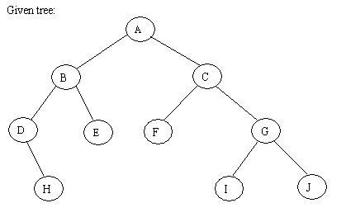 |  | 9
 | (b) | Define a binary search tree (BST). Write down the algorithm to add a node to BST. |  | 3+8
2. | (a) | What is the need for Priority queue? State the properties of heap. |  | 3+3
 | (b) | Write an algorithm to arrange an array of items into sorted order using a Heap. |  | 14
3. | (a) | Determine the Big O( ) notation for the following: (the first one is an example done for you)  (i) n³ + n¹⁰ O(n¹⁰ ), (ii) 0.001n³ + n + 1.999n³, (iii) 10n³ + 2n⁵+ 200n+ 30n³, (iv) Linear Search, (v) Heap Sort, (vi) Bubble Sort |  | 5
 | (b) | Proof that for an array of n elements, the worst-case time for binary search is logarithmic. |  | 12
 | (c) | In the given binary tree, using array you can store the node 4 at which location? |  | 3
 |  | 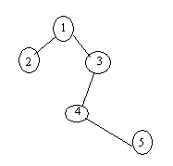
  1 | ? | ? | ? | ? | ? | ? | ? | ?
4. | (a) | Give the adjacency list representation for the following.  A  Ba  Ca  D |  | 4
 | (b) | What are the advantages of graph representation while using Adjacency Matrix (Array based Representation) and Adjacency List (Linked list based Representation)? |  | 4
 | (c) | For the given graph, show the traversal order in the DFS and BFS starting from node a.  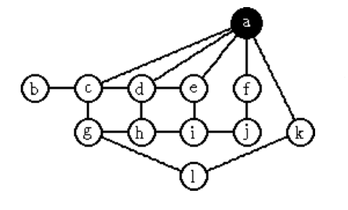 |  | 12

